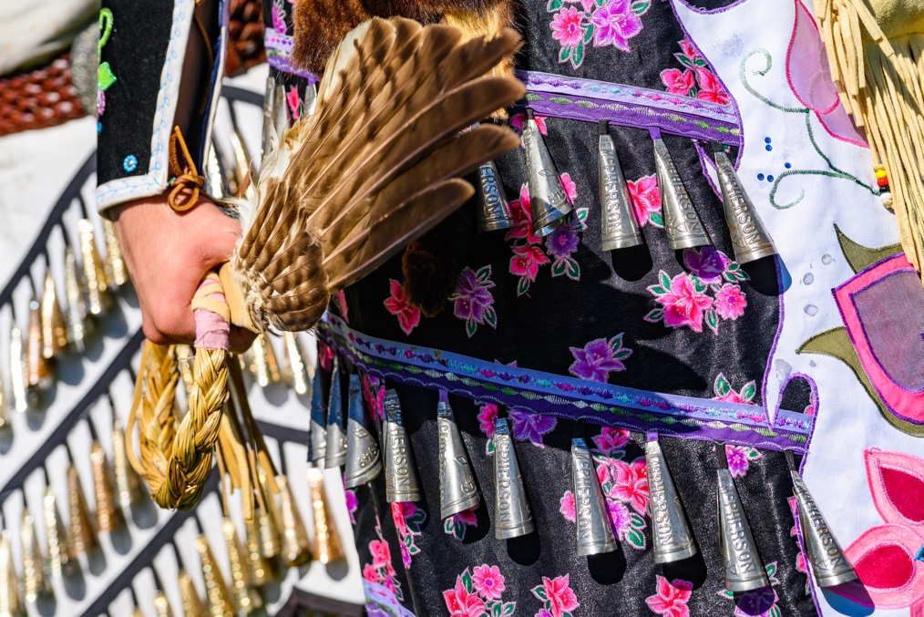

North American Indigenous Student Organization Hosts Powwow of Love

The North American Indigenous Student Organization hosted the [37th annual Powwow of Love](http://www.powwowoflove.com/) on Saturday, Oct. 1, at the IM East Field. Powwow is a social gathering with dances, feasting and singing held by North American Indigenous and First Nations communities. These gatherings facilitate cultural exchange between other Indigenous cultures across the globe and increases cultural awareness for non-Natives.

This year’s event is the first powwow since the beginning of the COVID-19 pandemic, bringing together hundreds of community members.

Many community members gathered on IM East Field to enjoy the festivities of the 37th annual Powwow of Love. The arena entrance is always situated to open to the eastern direction.

Dancers Jamie John, on left, and Tera John of the Grand Traverse Band of Chippewa Indians in a jingle style dress.

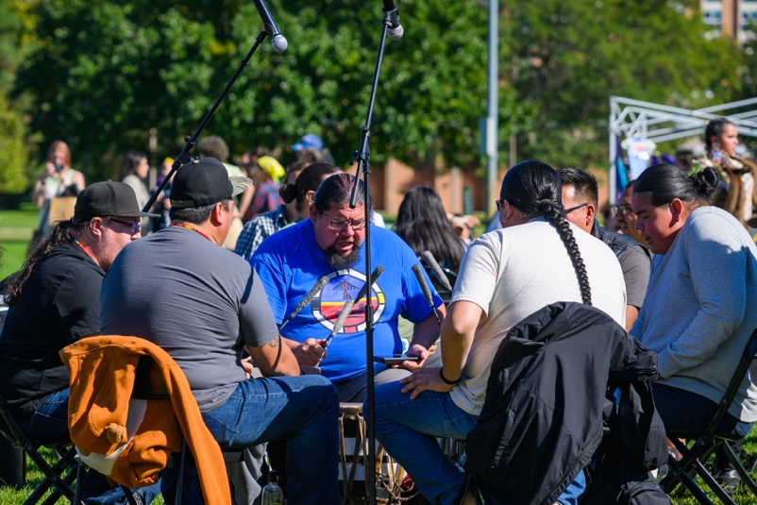

Drummers sat in the middle of the circle while dancers always move clockwise around the central heartbeat of the drums.

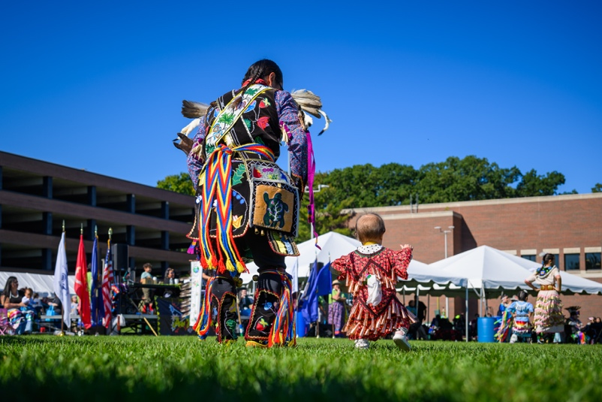

Children join in to learn cultural practices from elders.

The silhouette of a dancer wearing a type of headdress known as the porcupine hair roach.